|  |  |  |  |  |  |  |  |  |  |  |
| --- | --- | --- | --- | --- | --- | --- | --- | --- | --- | --- |
| **Leeds University**  **Business School** | |  | | | | | | | | |
| **Assessed Coursework Coversheet** | | | | | | | | | | |
| For use with *individual* assessed work | | | | | | | | | | |
| Student ID Number: | 2 | | 0 | 1 | 5 | 9 | 6 | 9 | 1 | 8 |
| Module Code: | LUBS3430 | | | | | | | | | |
| Module Title: | Modern Theories of Money | | | | | | | | | |
| Module Leader: | Guiseppe Fontana | | | | | | | | | |
| Declared Word Count: | 2,959 | | | | | | | | | |
| **Please read the following carefully and be accurate in your responses; they are all important:**   |  |  | | --- | --- | |  | **Delete as appropriate** | | By submitting this work I declare it is all my own work, other than where indicated by references. I have not colluded with others, re-submitted past work of my own, submitted any work done by others or by Generative AI unless indicated, or otherwise breached the University academic integrity rules. I understand that any discrepancies between this declaration and the assignment could result in an academic malpractice procedure.  Read the full University of Leeds declaration of academic integrity here <https://secretariat.leeds.ac.uk/wp-content/uploads/sites/109/2022/12/academic_integrity.pdf> | YES | | My declared word count is accurate and I have not attempted to mislead. I understand that making a fraudulent statement about word count could result in an academic malpractice procedure, and/or may impact the mark. | YES | | I have applied for an extension but have not heard yet whether it is granted. I am submitting this paper in the knowledge that I may request to submit a later version, if extension granted. Markers should be aware that this may not be my final version of the assignment. (Please indicate length of extension requested too, so we know when to expect updated submissions – delete two leaving the correct one visible) | NO | | I am aware of the Generative AI category for this assignment (delete two, leaving the correct one visible), and have adhered to the guidance for that category. | RED |   **Assignments should be submitted in time but will be accepted (with late penalties) up to 14 days after deadline.** Late penalties = 5 marks per 24hours late, down to a minimum of the bare pass mark (if pass standard). | | | | | | | | | | |

Discuss the endogenous money-led macroeconomic model and its policy implications. Illustrate your answer using relevant diagrams and/or equations.

In this paper I will explain the endogenous money model (EMM), discuss competing post-Keynesian endogenous money schools, with Palley (1994; 1998; 2001) and Dow (2006) representing the structuralist side and Lavoie (2006) the accommodationists. Conflicting frameworks will be used to analyse a credit crunch.

**Explaining the EMM**

**Financial markets**

The financial markets in the EMM are described in Figure I.

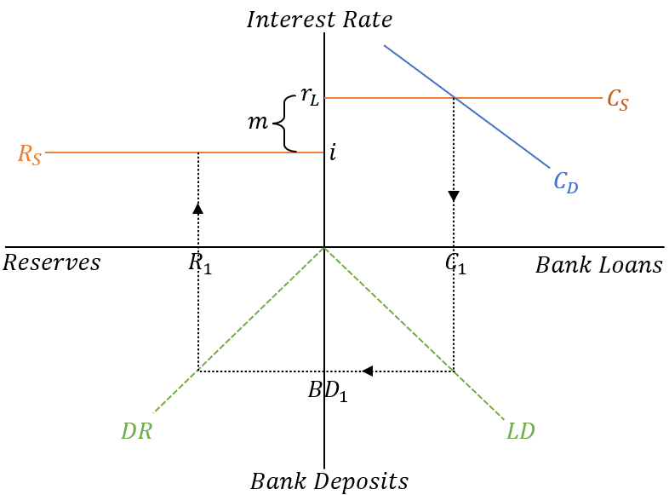

Figure – adapted from (Fontana & Setterfield, 2009, p. 147)

We begin in the top-right quadrant which shows equilibrium in the credit market: $C_{S}=C_{D}$. Demand for credit is perfectly accommodated by commercial banks at a rate $r_{L}=\left(1+μ\right)i$ where $μ$ is a mark-up charged over the central bank’s reserve rate $i$. $C_{S}=C_{D}$ such that there are $C_{1}$ bank loans. Once these loans are deposited into accounts, there are $BD1$ demand deposits for which banks demand $R_{1}$ reserves, either due to legal requirements or liquidity concerns. The exact ratios of loans-to-deposits and deposits-to-reserves are given by LD and DR and set to unity for simplicity.

**Goods Market**

The goods market is described by the equilibrium between aggregate demand and aggregate supply; see Figure IV below.

To derive AD in $[y,P]$ space, we start with the important equation:



$AD=ND+cD$

This recognises that all demand in an economy is either debt or non-debt financed, $cD$ and $ND$ respectively. We assume $ND=0$ for the sake of simplicity. $cD=f(r_{L}^{-})$, i.e., $cD$ is a negative function of the interest rate[1] where is the proportion of credit worthy borrowers and $D$ is total debt-financed demand.

The second necessary equation to derive AD in $[y,P]$ is:

$i=g(P^{+})$

This describes the central bank’s monetary rule and associates an interest rate with a price level.

We can connect the goods market and financial markets with:

$cD≡C_{D}$

As a result, we obtain Figure II.

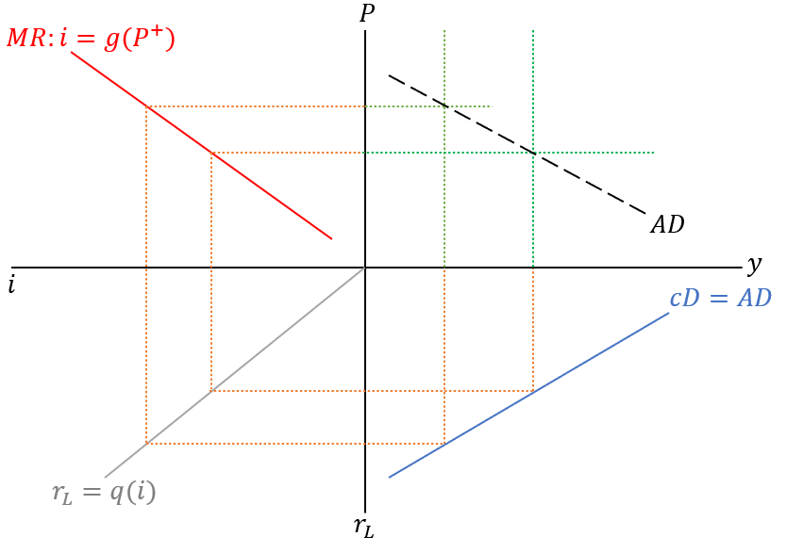

Figure – adapted from (Fontana & Setterfield, 2009, p. 151)

The slope of $AD$ is a policy construct based on equation (2). This is seen when comparing Figure II and Figure III.

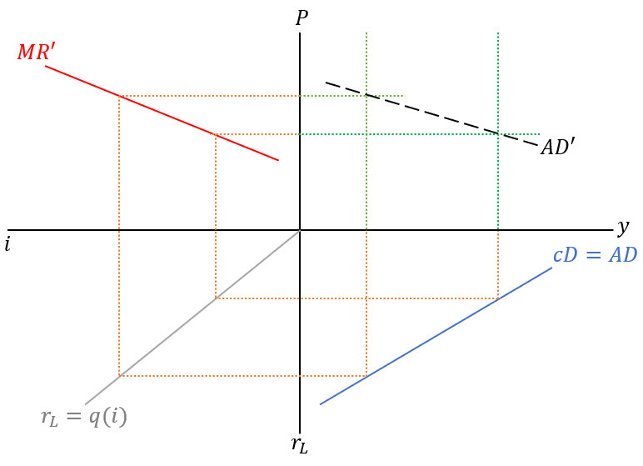

Figure - Figure II with a rotated MR curve

Aggregate supply in $[y,P]$ space is derived from firm pricing behaviour. Prices are equal to a mark-up set on average costs of production – labour is assumed as the only input cost.

$P=\left(1+m\right)\left(\frac{WN}{Y}\right)$

$\frac{WN}{Y}$ is assumed fixed in the short-run due to contractual and productivity rigidities.

Combining AD and AS gives us Figure IV. Equilibrium in the goods market gives us output $Y$ out of a maximum of $Y_{L}$.

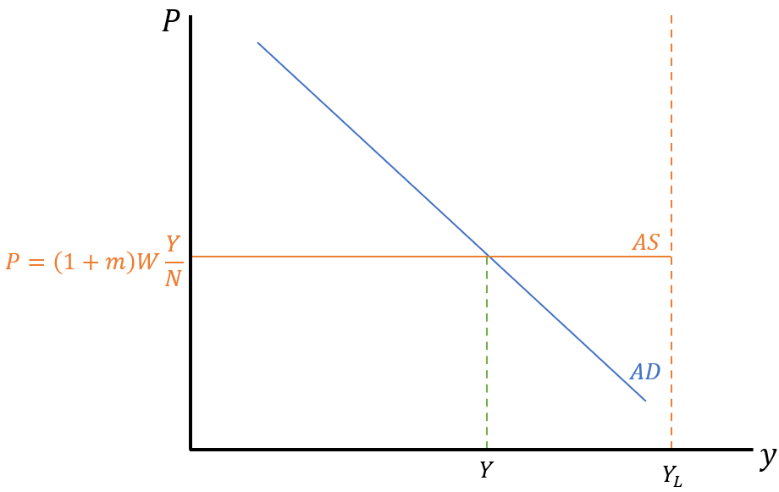

Figure – adapted from (Fontana & Setterfield, 2009, p. 153)

**Production and Labour Markets**

To find the level of labour employment given output, we use the aggregate production function which associates a level of output $y$ with capital $K$ and labour $N$. See Figure V.

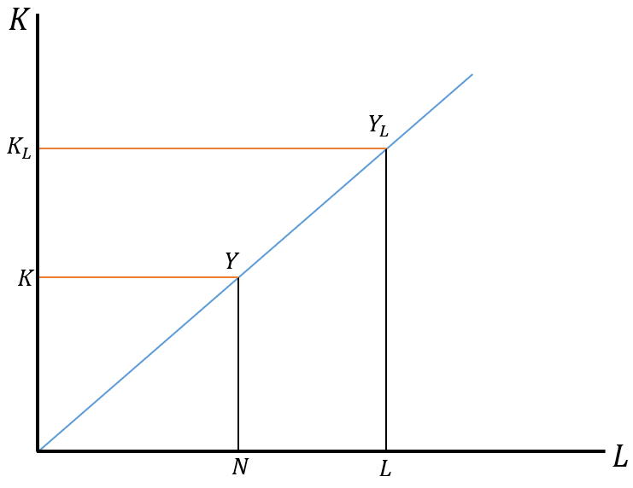

Figure – adapted from (Fontana & Setterfield, 2009, p. 152)

The labour market is shown in Figure VI.

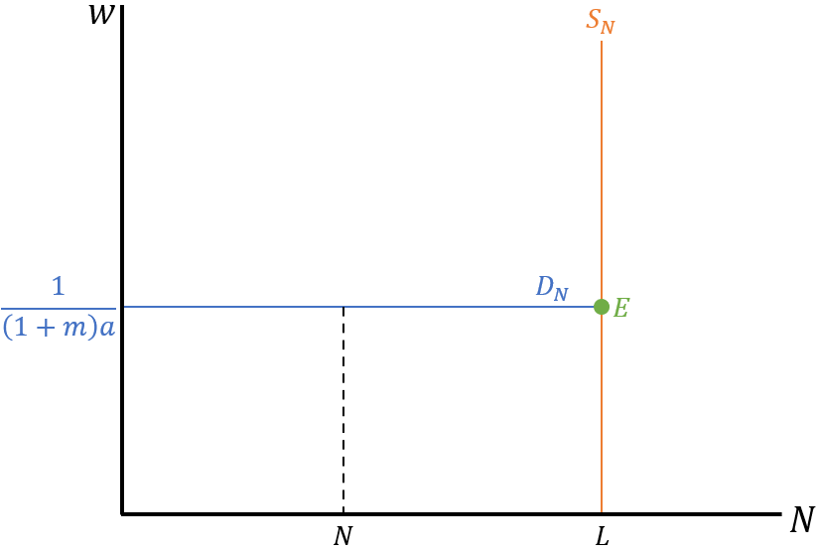

Figure – adapted from (Fontana & Setterfield, 2009, p. 155)

The labour supply is assumed to be perfectly inelastic, equal to the total active labour force $L$.

While the full employment equilibrium $E$ would be reached if firms hired the full labour supply, the goods market equilibrium means employment is stuck at $N$: unemployment $U=L-N$.

The real wage is found by rearranging (4) into:

$\frac{W}{P}=\frac{1}{\left(1+m\right)a}=w$

Where $a=\frac{N}{Y}$.

**Policy Implications**

**Structuralists and accommodationists**

Initially, endogenous money theory was not focused specifically on the microeconomics of bank and central bank behaviour (Palley, 2001, p. 163). The accommodationist/structuralist split, though, led to debate over the slope of the credit and reserve supply curves, $C_{S}$ and $R_{S}$ (Fontana, 2003, p. 293). Palley (1994, pp. 74-76) suggests the debate is really over whether the slope of these curves is dictated simply by a central bank response function (accommodationist), or banks’ and borrowers’ private behaviour, independent of the monetary authority (structuralists).

Accommodationists maintain that the best way to depict the $C_{S}$ and $R_{S}$ curves “remains a horizontal line, at the target overnight rate.” (Lavoie, 2006, p. 23). Lavoie (*ibid*) argues that policy rate setting decisions are not inherently tied to levels of output, capacity utilisation, or any general rule at all – they are bureaucratic decisions and consequently the most we can know is that between periodical rate changes the central bank perfectly accommodates liquidity at the chosen rate: $R_{S}=i$. Commercial banks then perfectly accommodate all credit demand at a given interest rate (Fontana [paraphrasing Moore (1988)]), 2003).

Structuralists like Dow (2006) argue that accommodationists have ignored Keynes’ theory of liquidity preference (Dow, 2006, p. 43). Dow (2006, p. 45) posits that risk-perceptions adjust at the macro-level via a Minsky process wherein correct profit expectations lead to falling liquidity preference from banks, shifting portfolios toward loans and lowering rates due to lower perceived default risks. This suggests a new equation, where mark-ups are a negative function of changes in profit expectations:

$μ=f{\left(\frac{∂E\left(Π\right)}{∂t}\right)}^{-}$

This means $C_{S}$ slopes down in a boom but up in a bust (Dow, 2006, p. 45). Interestingly, Palley (1994, p. 78) disagrees with Dow (2006) on this new equation:

“If the default risk rose with lending, then the aggregate loan supply schedule would be positively sloped for reasons totally unconnected with ‘structural’ endogeneity. […] It would also be sloped in the [accommodationist] model since the mark-up would rise with lending.”

Palley (1994, p. 76; 2001, p. 170) instead focuses on banks’ endogenous liability and asset managing behaviour, arguing that accommodationists take for granted the idea that economic agents will willingly hold deposits created from loans. Assuming that agents switch between demand deposits, time deposits, non-bank liability assets, or repayments *depending on interest rates*, then banks will, in response to increased loan demand, increase interest rates to change the correct proportion of demand deposits into time deposits and economise on reserves.

Palley (1994, pp. 76-77) thus prefers the following equations:



$r_{L}=\left(1+μ\right)i+f{\left(C\right)}^{+}$

$LD(r_{L})$

I agree with Palley that explicit focus on default risk when examining the structuralist viewpoint misses an analysis of the banking system’s specific micro-behaviour for a more generalist Minskyan idea. In doing so, structuralists ignore interesting complications from (7) and (8) which change Figure I into Figure VII.

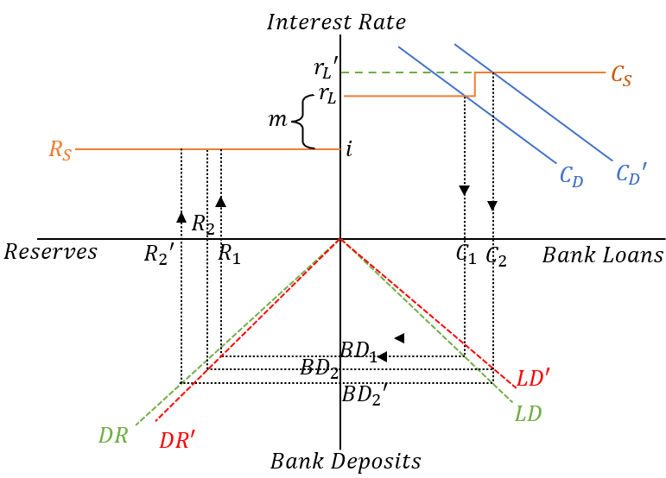

Figure - Figure I including Palley’s equations

In the new model, banks charge the higher interest rate $r_{L}'$, simultaneously increasing rates on time deposits. This increases the loan multiplier (Palley, 2001, p. 171) rotating $LD→LD'$ and encouraging a switch into time deposits. Because time deposits necessitate fewer reserves, the $DR$ schedule rotates to $DR'$. Banks now only borrow $R_{1}-R_{2}$ where they would otherwise have borrowed $R_{1}-R_{2}'$ and can accommodate the new loan demand $C_{D}'$ (Palley, 2001, p. 171).

One important policy recommendation from Palley (2001, p. 177) are regulatory controls to restrict the loan expansion process shown in Figure VII. Conflicting implications will be explored when analysing a credit crunch.

**General Policy Implications**

The most important general policy implication of the EMM is that fiscal policy can be an effective tool for growth and stability, and should not be relegated to a budget-balancing exercise. Fontana and Setterfield (2009) use the EMM to analyse a credit crunch but tackle it through an accommodationist paradigm – I will examine it using a structuralist framework.

In a credit crunch, banks have increased mark-ups (either due to a shift factor (Lavoie, 2006), or a slope (Dow, 2006)) and restricted lending criteria, decreasing $c$; see Figure VIII.

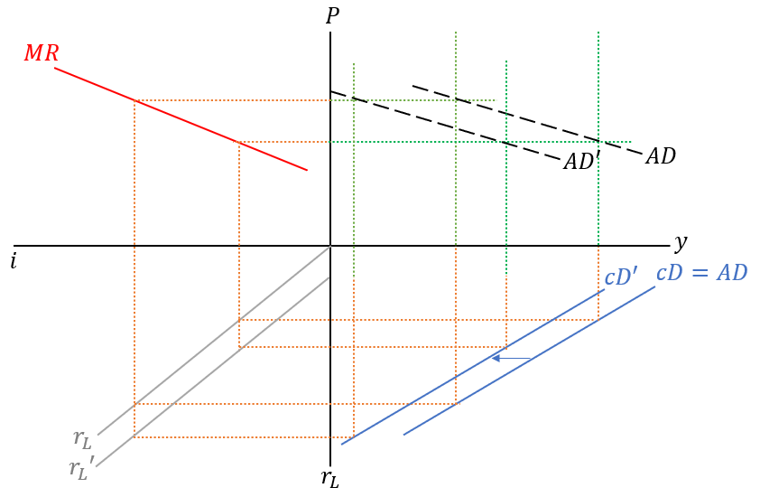

Figure – A credit crunch

Next, the mark-up $μ$ becomes unstable due to very high risk premia, kinking the stable relationship between $r_{L}$ and $i$ at $i_{t}$, which is the policy rate at the time of the crunch; see Figure IX.

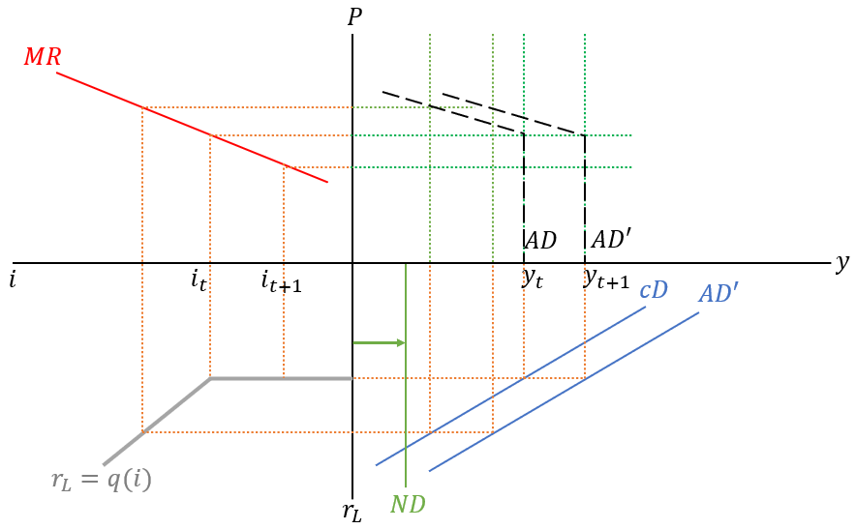

Figure – Updated Figure II.

If the central bank decreases the policy rate from its current position to $i_{t+1}$ to stimulate AD, this has no effect on the market rate $r_{L}$, and no effect on demand: output stays at $y_{t}$. However, AD needs to increase to re-anchor mark-ups and reverse falling profit expectations; therefore, fiscal stimulus is necessary and $ND$ rises shifting $AD→AD'$.

A structuralist framework adds some policy complications if we assume that, by increasing $ND$, the government also increases the incomes of household and thus boosts $cD≡C_{D}$ via a multiplier effect. This would raise rates; see Figure X.

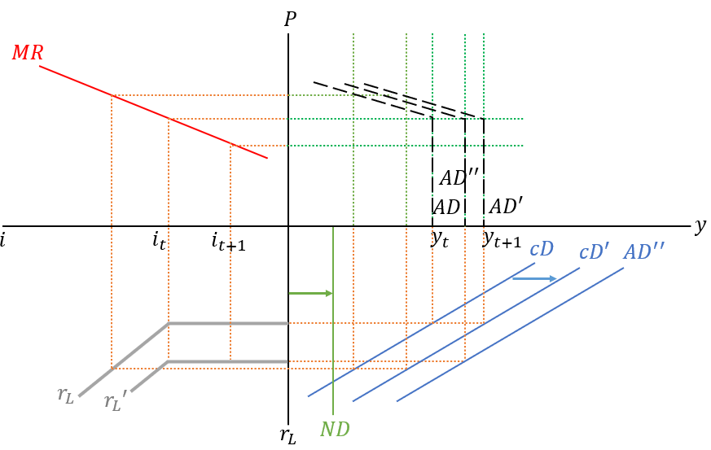

Figure – crowding out

Rates rise drastically from $r_{L}→r_{L}^{'}$ if banks face difficulty accommodating $cD^{'}≡C_{D}'$, causing a partial crowding-out effect as $AD$ rises but then falls from $AD→AD^{'}→AD''$. Difficulty accommodating loans could occur if consumers are less willing to hold time deposits due to faith in the banking system being shaken – this increases the quantity of reserves banks need to borrow to ensure the liquidity of demand deposits.

When risk and profit expectations readjust, $μ$ will again become fixed – unkinking $r_{L}$– and diminish. However, because government stimulus may induce a higher rate of interest during the recovery period *ceteris paribus*, a structuralist framework advocates for some caution in the quantity of stimulus.

In conclusion, the EMM model provides policy makers with a new perspective to analyse recessions and fiscal stimulus. In this paper I have outlined the EMM and introduced important equations and diagrams to connect financial, goods, and labour markets with output. I then outlined the conflicting policy implications originating from the structuralist/accommodationist split in an analysis of a credit crunch, showing that an imperfectly elastic credit supply function could complicate fiscal stimulus programs.

Discuss Minsky's Financial Instability Hypothesis about the nature and origin of financial crises in modern economics

In this paper I will explain Minsky’s Financial Instability Hypothesis (FIH) and extend it to include a model of ‘cash-in-the-market pricing’ developed by Allen & Gale (2007).

The Financial Instability Hypothesis models the economy such that exogenous shocks are not necessary to generate business cycles (Minsky, The Financial Instability Hypothesis, 1992). Instead, business cycles are endogenous. Minsky (2008) begins with a monetary theory of production, i.e., firms must acquire finance to produce goods; see Figure XI.

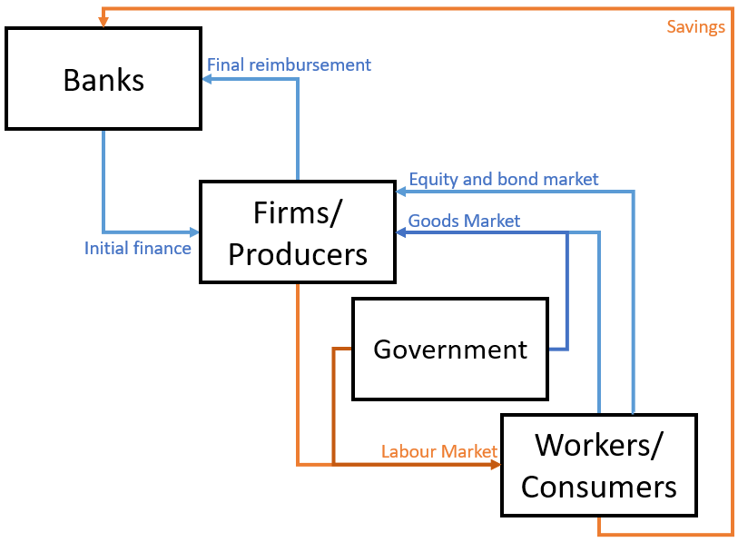

Figure XI – adapted from (Realfonzo, 2006, p. 107)

Arrows indicate monetary flows; flows which help firms repay debt commitments are in blue, flows which hinder them are in orange. Bear in mind:

1. Firms’ costs are labour and capital, but capital expenditure circulates amongst firms,
2. We assume banks do not spend their interest earnings,
3. Taxes paid to the government are not shown here.

For firms, the banks’ initial finance creates a definite final reimbursement obligation. However, firms do not necessarily know whether they will be able to fulfil this commitment: to reimburse banks, earnings by firms in the goods, equity and bond markets must be more than or equal to the quantity spent in the labour market (plus interest). Therefore, firms’ ability to honour debt commitments depends on consumer and the government behaviour. These factors are uncertain and banks therefore lend based on firms’ profit expectations; see Figure XII.

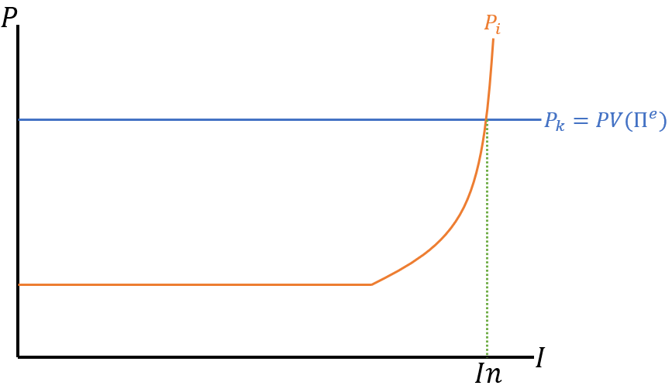

Figure XII – adapted from (De Antoni, 2006, p. 157)

Figure XII models the demand and supply price of capital assets. The demand price $P_{k}$ is equal to the present value of future profit expectations $PV(Π^{e})$ from operations; if $P_{k}>PV\left(Π^{e}\right)$, investors make a loss, so $P_{k}=PV(Π^{e})$ the maximum price willing to be paid. The supply price $P_{i}$ is the marginal cost of asset production which eventually curves upward due to diminishing marginal productivity.

For simplicity, assume we are at the start of the monetary circuit. Firms cannot make investments $In$ as they have no access to funds and consumers have no earnings to buy equity or bonds; banks therefore provide all financing; see Figure XIII.

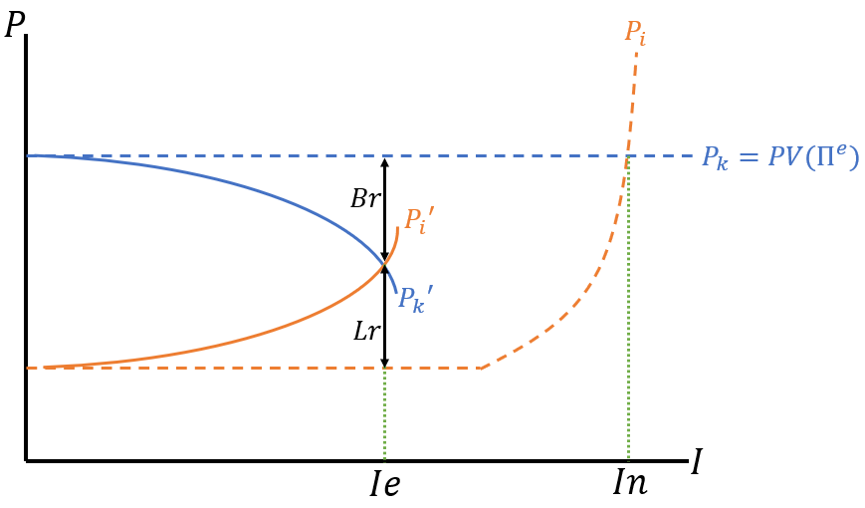

Figure XIII – adapted from (De Antoni, 2006, p. 157)

In Figure XIII, borrower risk $Br$ and lender risk $Lr$ are priced into investment decisions. $Lr$ is expressed as an increased interest rate on loans pushing up the firms’ perceived asset cost $P_{i}→P_{i}'$, and $Br$ is the cash-flow margin desired by firms to accept risk (Minsky, 2008, pp. 213-4). $Br$ and $Lr$ increase with the size of the investment until they meet at an equilibrium level of investment $Ie$.

If firms experience an unexpected but seemingly permanent increase in profits (a boom), profit expectations and confidence in firms will shift the diagram to Figure XIV (De Antoni, 2006, p. 160).

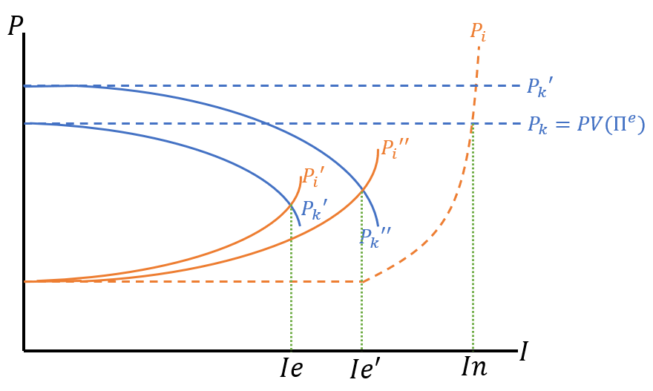

Figure XIV - adapted from (De Antoni, 2006, p. 160)

For the sake of simplicity, we again ignore equity and bond markets. Increased profit expectations shift $P_{k}$ to $P_{k}'$ and increased confidence decreases $Br$ and $Lr$ for the same level of investment. These changes combine and $Ie$ increases to $Ie'$.

Minsky (2008, p. 230) posits that some firms and their bankers will speculate on these potential booms. Minsky (*ibid*) defines three categories:

1. Hedge,
2. Speculative,
3. Ultra-speculative or ‘Ponzi’.

These can be described with a novel diagram, see Figure XV.

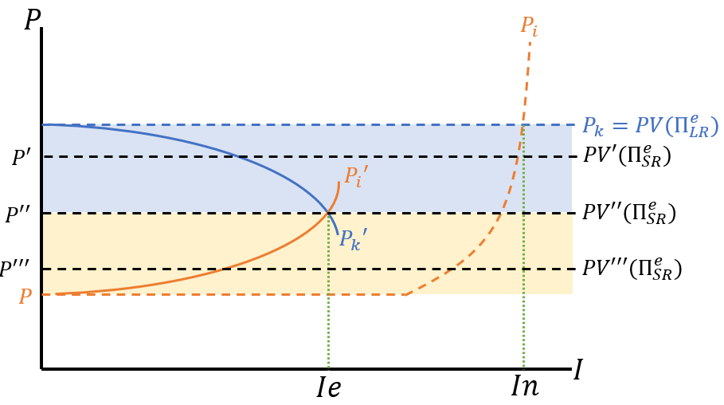

Figure XV – own illustration, adapted partly from (De Antoni, 2006)

Figure XV delineates long-run and short-run profit expectations.

$$P^{''}=r=i+x$$

Where the market rate $r$ is equal to the risk-free rate $i$ plus a risk premium $x=Lr$. Minsky (*ibid*) defines hedge investors as agents who are not dependent on finance after the initial loan: they receive sufficient cashflow to repay interest and the principal: $PV^{'}\left(Π_{SR}^{e}\right)>r$. Speculative investors have $PV^{''}\left(Π_{SR}^{e}\right)=r$ and roll-over their debt until long-run expectations are realised; Ponzi investors have $PV^{'''}\left(Π_{SR}^{e}\right)<r$ and require new loans to stay solvent in the short-run.

Speculators exceeding profit expectations eventually leads to the endogenous accumulation of financial fragility. During the upswing, speculators prove to banks that their projected long-run expectations were valid. Meanwhile, hedgers will realise they did not fully utilise available leverage and are incentivised to do so. As a result, firms become increasingly reliant on the financial sector to roll-over debt or maintain a flow of credit.

When expectations are not met, due to either reduced government spending or increased consumer savings, there is a ‘Minsky moment’. Liquidity preference across the entire economy rises precipitously due to strong uncertainty, meaning that: consumers save more in banks, rather than via the equity and bond market; banks shift from illiquid loans to liquid investments such as treasuries; and firms demand financing to service their debt and meet their ballooning risk margin $Br$ (Dow, 2006, p. 41). Firms do not attain extra financing due to banks’ unwillingness to lend and must sell capital assets. This causes a spiral of debt-deflation, wherein asset prices collapse due to excess supply, requiring firms to sell more to meet their debt commitments.

Ultimately, not all commitments can be fulfilled and there will be a wave of bankruptcies, followed by a recovery period dominated by hedged investment until the cycle repeats. Some critics argue such a cyclical nature would require people to behave irrationally, never learning from mistakes; however, this is not a necessary assumption. As Skott (1996, p. 270) notes, knowledge from past mistakes does not help with present situations: past crises lead to changes in the institutional environment wherein novel innovations will render previously risky actions safe, and safe actions risky. Agents trying to extrapolate from past experiences will be “in the positions of generals using the strategies of a previous war.” (*ibid*).

**Expanding Minsky to account for liquidity uncertainty**

Allen & Gale (2007, p. 20) suggest two mechanisms which can crash asset prices: falling future returns, and unexpected liquidity shocks. Minsky is primarily concerned with the former, however Allen & Gale’s (2007) ‘cash-in-the-market pricing’ model shows that liquidity shocks can cause crashes to occur even when asset returns are certain. By extending Minsky’s FIH to include both mechanisms, it can better model financial crises.

Cash-in-the-market pricing occurs when there is a liquidity shortage and the asset price becomes equal to the ratio of available liquidity to the amount of the asset supplied. Allen & Gale (2007, p. 104) model a liquidity shock by assuming there exist a large number of agents represented by the unit set $[0,1]$ delineated into $λ$ early consumers and $(1-λ)$ late consumers who invest in either:

* The short asset, representing a storage technology for cash earning no interest,
* The long asset, representing a productive investment with a two-period lag.

Consumers invest $x≥0$ units in the long asset and $y≥0$ in the short asset at period 0 such that $x+y=1$. The short asset matures in period 1, the long asset at period 2. A liquidity shock occurs because consumers do not know whether they are early or late consumers until period 1. Furthermore, a state of nature is randomly selected between $s_{H}$ where there are $λ_{H}$ early consumers and $s_{L}$ where there are $λ_{L}$ early consumers such that $0<λ_{L}<λ_{H}<1$. Agents in this model are, however, aware of the probability distributions.

Early consumers will sell all long assets in period 1, while late consumers will use matured cash assets to buy long at price $P$. In period 2, late consumers receive $xR$ where $R$ is the return on production. Allen & Gale derive supply and demand prices $P$ for the long asset in period 1; see Figure XVI.

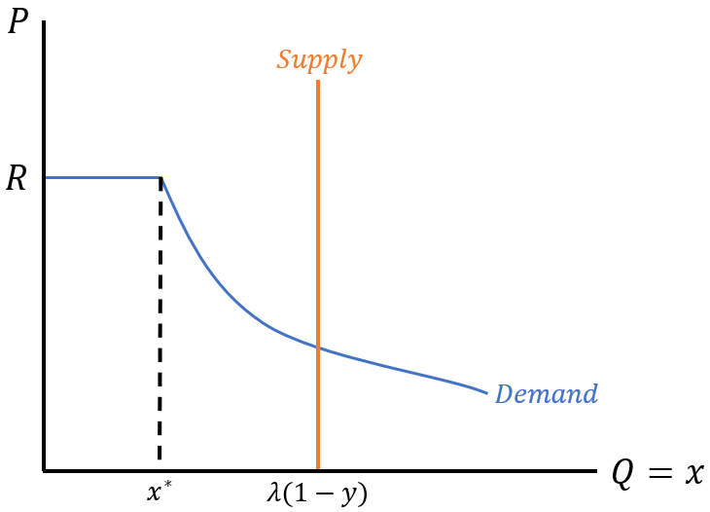

Figure XVI – adapted from (Allen & Gale, 2007, p. 110)

Supply is fixed at $λ\left(1-y\right)$, i.e., $λx$, as this is the quantity of long assets held by early consumers. The demand line’s curved section shows cash-in-the-market pricing: if there are $x>x^{*}$ long assets available, there is an inverse quantity of short assets, i.e., initial overinvestment in illiquid assets by agents leads to a future shortage of liquidity. Allen & Gale (2007, p. 111) show the relationship between $P$ and liquidity preference with parameters: $R=1.2,λ_{L}=0.5,λ_{H}=0.67$; see Figure XVII.

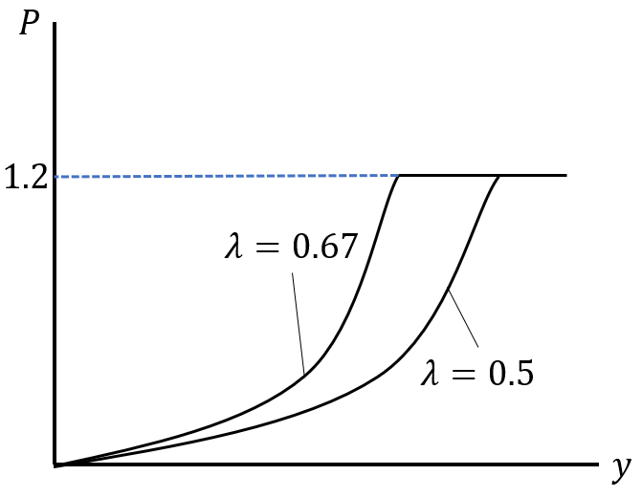

Figure XVII – adapted from (Allen & Gale, 2007, p. 111)

This shows that greater initial liquidity preference incurs less cash-in-the-market pricing.

Adapting Figure XVI to Minsky, we set $R=PV(Π_{LR}^{e})$ and modify the supply curve so that the long asset is produced rather than fixed in quantity. Agents are no longer aware of probability distributions, instead forming future liquidity preference expectations; see Figure XVIII.

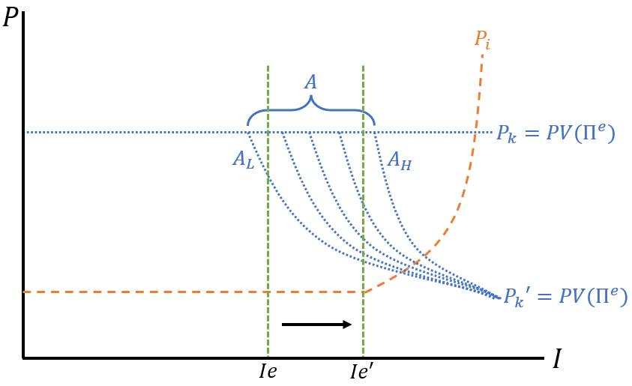

Figure XVIII – own illustration

$A$ denotes possible $P_{k}$ schedules following a sudden liquidity restriction. During an economic upswing, liquidity preference decreases because firms honour debt commitments, making assets like loans and fixed investments preferred to cash – Figure XVII shows this shifts firms closer to $A_{L}$ because low liquidity preference will cause harsher cash-in-the-market pricing. Meanwhile, investment is expanding from $Ie→Ie'$. Combining these facts, we can conclude that the longer a boom presides, the more likely it is that capital assets experience cash-in-the-market pricing following a liquidity shock. A debt-deflation spiral follows if banks lose confidence in firms’ profit expectations.

To surmise, I have explained the fundamental theory of the Financial Instability Hypothesis and demonstrated how it can be combined with Allen & Gale’s (2007) cash-in-the-market pricing model to incorporate liquidity preference uncertainty. This allows liquidity shocks to also be endogenised to the model, providing a fuller explanation of financial crises.

# Bibliography

Allen, F., & Gale, D. (2007). *Understanding Financial Crises.* Oxford: Oxford University Press.

De Antoni, E. (2006). Minsky on Financial Instability. In P. Arestis, & M. Sawyer, *A Handbook of Alternative Monetary Economics* (pp. 154-171). Cheltenham: Edward Elgar Publishing Limited.

Dow, S. C. (2006). Endogenous Money: Structuralist. In P. Arestis, & M. Sawyer, *A Handbook of Alternative Monetary Economics* (pp. 35-51). Cheltenham: Edward Elgar Publishing Limited.

Fontana, G. (2003). Post Keynesian Approaches to Endogenous Money: A time framework explanation. *Review of Political Economy*, 291-314.

Fontana, G., & Setterfield, M. (2009). A Simple (and Teachable) Macroeconomic Model with Endogenous Money . In G. Fontana, & M. Setterfield, *Macroeconomic Theory and Macroeconomic Pedagogy* (pp. 144-168). Palgrave Macmillan.

Lavoie, M. (2006). Endogenous Money: Accommodationist. In P. Arestis, & M. Sawyer, *A Handbook of Alternative Monetary Economics* (pp. 17-34). Cheltenham: Edward Elgar Publishing Limited.

Minsky, H. P. (1992). *The Financial Instability Hypothesis.* The Jerome Levy Economics Institute of Bard College.

Minsky, H. P. (2008). *Stabilizing an Unstable Economy.* New York: McGraw Hill.

Moore, B. (1988). *Horizontalists and Verticalists: the macroeconomics of credit money.* Cambridge: Cambridge University Press.

Palley, T. (1994). Competing Views of the Money Supply Process: Theory and Evidence. *Metroeconomica*, 1-95.

Palley, T. (1998). Accommodationism, Structuralism, and Superstructuralism. *Journal of Post Keynesian Economics*, 171-173.

Palley, T. (2001). Endogenous Money: What it is and why it matters. *Metroeconomica*, 152-180.

Realfonzo, R. (2006). The Italian Circuitist Approach. In P. Arestis, & M. Sawyer, *A Handbook of Alternative Monetary Theories* (pp. 105-120). Cheltenham: Edward Elgar Publishing Limited.

Skott, P. (1996). Financial Innovation, Deregulation and Minsky Cycles. In G. Epstein, & H. Gintis, *Macroeconomic Policy after the Conservative Era* (p. Chapter 9). Cambridge: Cambridge University Press.

1. Throughout the paper, $y=f(x^{+})$ or $y=f(x^{-})$ will denote the sign of the partial derivative .